How to use Heroku?

1. download heroku toolbelt and install it,
2. 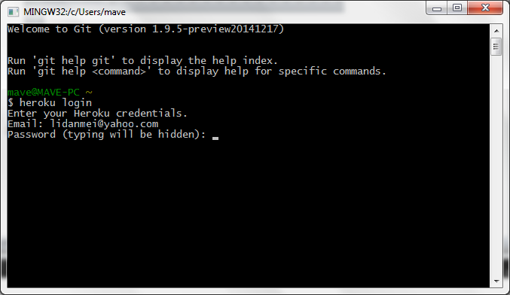
3. Prepare the app
4. In this step, you will prepare a simple application that can be deployed.
5. Execute the following commands to clone the sample application:
6. $ git clone https://github.com/heroku/node-js-getting-started.git
7. $ cd node-js-getting-started
8. You now have a functioning git repository that contains a simple application as well as a package.json file, which is used by Node’s dependency manager.
9. [Log in to report a problem](https://devcenter.heroku.com/login?back_to=%2Farticles%2Fgetting-started-with-nodejs%23prepare-the-app) [My app is ready](https://devcenter.heroku.com/articles/prepare-the-app)
10. ([Log in](https://devcenter.heroku.com/login?back_to=%2Farticles%2Fgetting-started-with-nodejs%23prepare-the-app) to save and track your progress)

Deploy the app

In this step you will deploy the app to Heroku.

Create an app on Heroku, which prepares Heroku to receive your source code.

$ heroku create

Creating sharp-rain-871... done, stack is cedar-14

http://sharp-rain-871.herokuapp.com/ | https://git.heroku.com/sharp-rain-871.git

Git remote heroku added

When you create an app, a git remote (called heroku) is also created and associated with your local git repository.

Heroku generates a random name (in this case sharp-rain-871) for your app, or you can pass a parameter to specify your own app name.

Now deploy your code:

1. Package.json file need to include node and npm version

{

"name": "angular-seed",

"private": true,

"version": "0.0.0",

"description": "A starter project for AngularJS",

"repository": "https://github.com/angular/angular-seed",

"license": "MIT",

"devDependencies": {

"karma": "~0.10",

"protractor": "^1.1.1",

"http-server": "^0.6.1",

"bower": "^1.3.1",

"shelljs": "^0.2.6",

"karma-junit-reporter": "^0.2.2"

},

"engines": {

"node": "0.12.2",

"npm": "2.9.1"

},

"scripts": {

"postinstallin": "bower install",

"prestart": "npm install",

"start": "http-server -a localhost -p 8000 -c-1",

"pretest": "npm install",

"test": "karma start karma.conf.js",

"test-single-run": "karma start karma.conf.js --single-run",

"preupdate-webdriver": "npm install",

"update-webdriver": "webdriver-manager update",

"preprotractor": "npm run update-webdriver",

"protractor": "protractor e2e-tests/protractor.conf.js",

"update-index-async": "node -e \"require('shelljs/global'); sed('-i', /\\/\\/@@NG_LOADER_START@@[\\s\\S]*\\/\\/@@NG_LOADER_END@@/, '//@@NG_LOADER_START@@\\n' + sed(/sourceMappingURL=angular-loader.min.js.map/,'sourceMappingURL=bower_components/angular-loader/angular-loader.min.js.map','app/bower_components/angular-loader/angular-loader.min.js') + '\\n//@@NG_LOADER_END@@', 'app/index-async.html');\""

}

}

1. The node and npm version should match the real node and npm version running in your machine.(in git command , type **node –v** or **npm –v** to find out)
2. In git, type: **npm install –save foobar** to make sure node_modules and package.json file match.